**MODULE-2**

DESIGN AND SIMULATION

OF CIRCUITS AND EMBEDDED SYSTEMS

PROJECT:

BLIND STICK

Submitted by:

BANDA THARUNYA REDDY

**Table of Contents**

**1.0 ABSTRACT** 2

**2.0 REQUIREMENTS** 3

2.1 Description: 3

2.3 Requirement Modelling: 5

2.3.1 High Level Requirements: 5

2.3.2 Low Level Requirements: 5

2.4 Working: 6

2.5 Applications: 6

**3.0 ARCHITECTURE** 6

3.1.1 Black Box: 7

3.2 Behavioural Diagrams: 7

3.2.1 Block Diagram: 7

3.2.2 Flowchart: 8

**4.0 TEST PLAN & OUTPUT** 9

4.1 Test Plan 9

4.2 Table 9

4.3 OUTPUTS 10

**5.0 CONCLUSION** 11

# **1.0 ABSTRACT**

Vision is the most important part of human physiology as 83% of information human being gets from the environment is via sight. Currently there are thousands of blind people all over the globe. They face difficulties while crossing the road or reaching their destination. There are 7 billion people in the world who are visually impaired. The mobility of visually impaired in unknown environment seems impossible without external help, because they don’t have any proper idea about their surroundings, so we are developing a smart walking stick which helps them to know about surroundings and also guide them during travelling. So that visually challenged people can feel the surroundings of world and live independently. So, we thought that our product can help blind people finding of way through a complex environment, provide the orientation and navigation for these people in unknown environment is and makes blind people are fearless or comfortable about independent mobility or travel.

The main objective is to help visually challenged people to navigate with ease using advance technology in controlled world where people strive to live independently.

1. To design a product that identifies the solid objects and people within range, especially identify the obstacle detection.

2. To identify threats like accidents

3. Gives buzzer sound to user to inform about obstacles.

# **2.0 REQUIREMENTS**

## 2.1 Description:

This is a project, which aspects the design of an blind stick which involves the ultrasonic sensor, led, and buzzer. The embedded system when installed and given to the blind people while going out or travelling, will sense the obstacles in their way and alerts them before they hurt. The Arduino Uno continuously checks for the communication from ultrasonic sensor. The led will be ON when the obstacle ahead and the distance from ultrasonic sensor are satisfied. Otherwise the led will be in OFF position.

**2.2 Components:**

* Arduino Uno.
* Ultrasonic (HC-SR04).
* LED/ any light source.
* 221 Ohms resistor.
* Buzzer.
* Bread board(optional).
* **Arduino Uno:** Arduino Uno is a microcontroller board based on the ATmega328P (datasheet). It has 14 digital input/output pins, 6 analog inputs, a 16 MHz ceramic resonator, a USB connection, a power jack, an ICSP header and a reset button.
* **Ultrasonic:** The HC-SR04 Ultrasonic Distance Sensor is a sensor used for detecting the distance to an object using sonar. The HC-SR04 uses non-contact ultrasound sonar to measure the distance to an object.
* **LED:** A light-emitting diode(LED) is a semiconductor light source that emits light when current flows through it.
* **Resistors:** A resistor is a passive two-terminal electrical component that implements electrical resistance as a circuit element. This project is done using 221 Ohms. The 221 Ohms resistor has the color code as red-red-brown-black/orange(tolerance).
* **Buzzer:** The buzzer is **a sounding device that can convert audio signals into sound signals**. It is usually powered by DC voltage.

## 2.3 Requirement Modelling:

### 2.3.1 High Level Requirements:

|  |  |
| --- | --- |
| **ID** | **Description** |
| HR01 | Sensor shall detect person. |
| HR02 | LED shall turn on. |
| HR03 | LED shall turn off. |

### 2.3.2 Low Level Requirements:

|  |  |  |
| --- | --- | --- |
| **ID** | **Description** | **HLR ID** |
| LR01 | The sensor detects whether the surrounding of a person has any obstacles. | HR01 |
| LR02 | The LED will be turned off if there is no obstacle ahead. | HR03 |
| LR03 | The controller(Arduino) turns on the LED if the sensor detects the obstcale and if a person is detected ahead of it. | HR02 |

## 2.4 Working:

The power supply is given to the system then the Arduino UNO will on and the ultrasonic sensor starts detecting obstacles. When the obstacle is ahead then the information is sent to Arduino and the LED will be on. Whenever, LED is on then the buzzer will give the sound so that the blind people will be alert. If the LED is off then the buzzer goes off so that the people can start moving in their way. This process will goes on until and unless the power supply is given to system.

## 2.5 Applications:

* Help blind people to easily walk to destination.
* Help blind people for obstacle detection.
* Alert blind people about dig.

# **3.0 ARCHITECTURE**

### 3.1.1 Black Box:

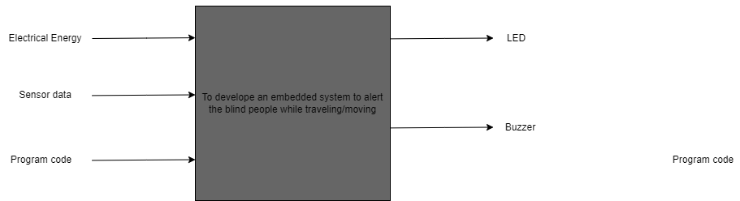

## 3.2 Behavioural Diagrams:

### 3.2.1 Block Diagram:

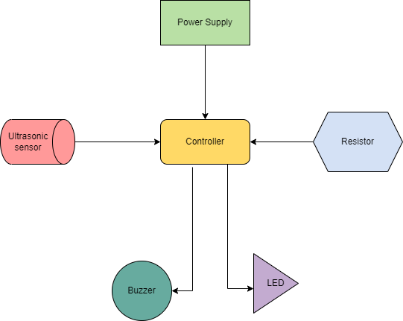

### 3.2.2 Flowchart:

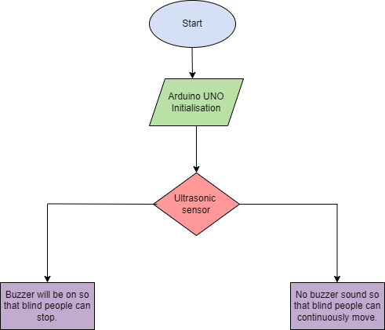

# **4.0 TEST PLAN & OUTPUT**

## 4.1 Test Plan

* For every feature, define a test case  
  👉 How to run that feature  
  👉 Define expected behaviour  
  👉 Capture the actual result

## 4.2 Table

* ID, Description of Test case, Input values, Expected Output, Actual Output & Status.

| **Test ID** | **Description** | **Input values** | **Expected Output** | **Actual Output** | **Status** |
| --- | --- | --- | --- | --- | --- |
| H_01 | Detecting Obstacles | Ultrasonic data values | Distance ranging between 1-50cm | Distance ranging between 1-50cm | ✅ |
| H_02 | LED turns ON | Ultrasonic data values | LED turns on if obstacle ahead | LED turns on if obstacle ahead | ✅ |
| H_03 | LED turns OFF | Ultrasonic data values | LED turns on if no obstacle ahead | LED turns on if no obstacle ahead | ✅ |

## 4.3 OUTPUTS

* Obstacle ahead and LED is ON

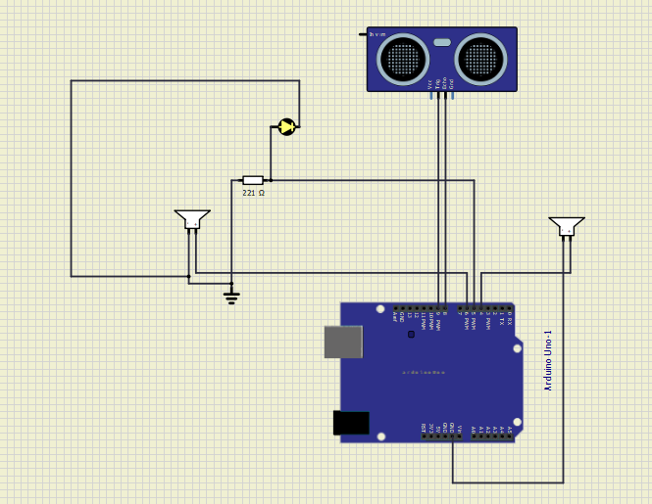

* No obstacle and LED is OFF

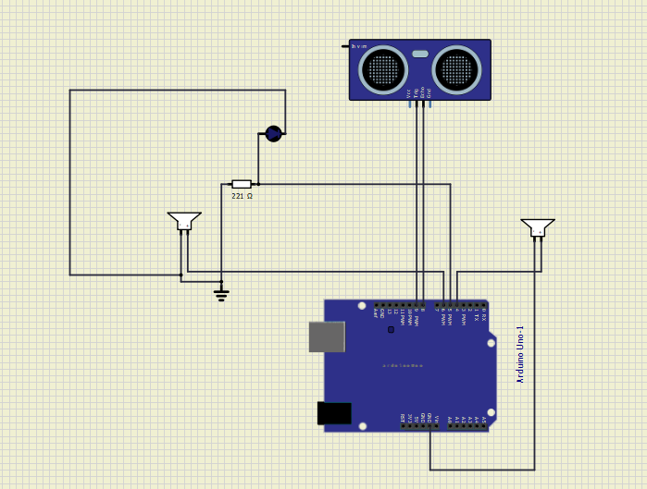

# **5.0 CONCLUSION**

* The project proposed the design and architecture of a new concept of guiding stick for blind people. The advantage of the system lies in the fact that it can prove to be very low cost solution to millions of blind person worldwide. The proposed combination of various working units make a real time system that monitors position of the user and provides dual feedback making alert more safe and secure.
* It can be further improved to have more decision taking capabilities by employing varied types to sensors and thus could be used for different applications. It aims to solve the problems faced by the blind people in their daily life. The system also takes measures to ensure their safety.